**All in one Desktop**

Asus Vivo V222F-AKWA135T 21.5" All-In-One Desktop PC

<https://shopee.com.my/Asus-Vivo-V222F-AKWA135T-21.5-All-In-One-Desktop-PC-(i3-10110-4GB-512GB-Integrated-W10H)-i.215214400.6861906816?sp_atk=c10c29bd-d140-47db-989b-6b20fa0c4424>

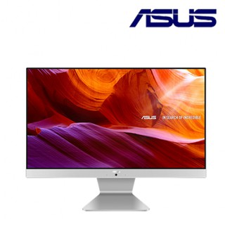

RM2,599.00

Acer All in One PC C24-1651-1115G4W10 (TOUCH SCREEN, I3-1115G4 4GB 512GB OPI 23.8" 1920 X 1080 KB+Mouse W10)

<https://shopee.com.my/ACER-ASPIRE-(-C241651-1135G7W11-C241651-1135G7W11T-)23.8-FHD-I5-1135G7-8GD4-512SSD-WIN11H-AIO-PC-(WITH-OPI-OFFICE)-i.213243429.8948503546?sp_atk=69d33cf4-013b-4a49-9748-143fcb757c7b>

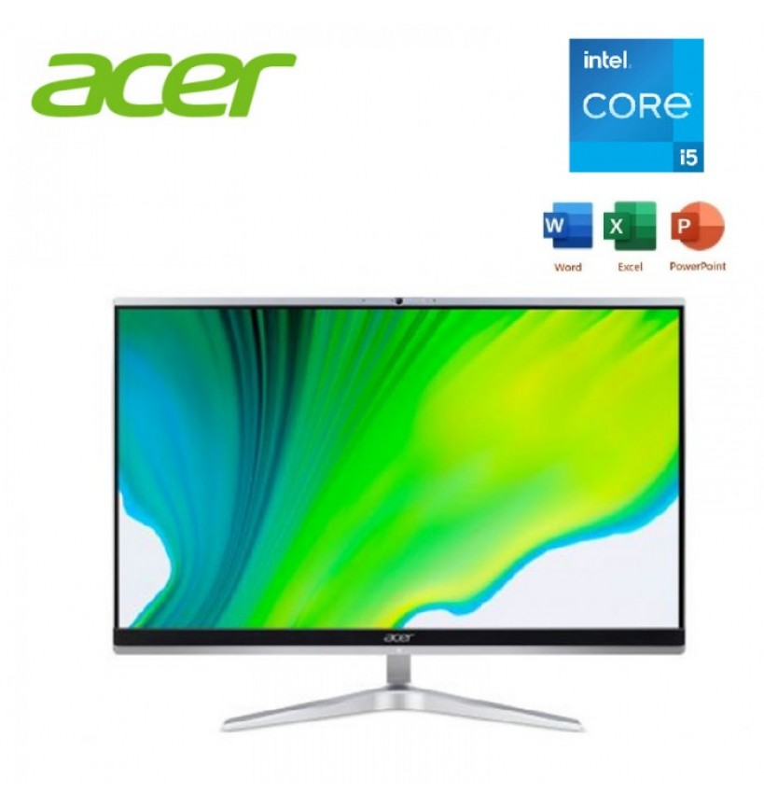

RM3,299.00

HP Pavilion 24/27 All in One PC Desktop 24-K1001D/27-K1007D/24-K1003D

<https://shopee.com.my/HP-Pavilion-24-27-All-in-One-PC-Desktop-24-K1001D-27-K1007D-24-K1003D-i.453535438.11039808770?sp_atk=3bb56c65-bbb8-42c9-91bb-b95e59070ce2>

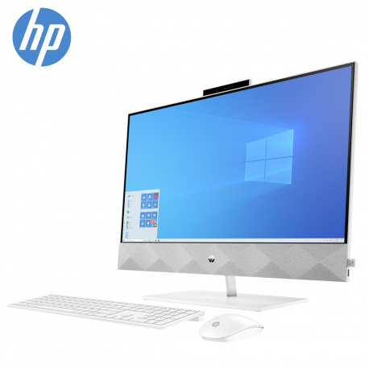

RM5,599.00

ACER ASPIRE ( C241651-1135G7W11)23.8" FHD I5-1135G7 8GD4 512SSD WIN11H AIO PC

<https://shopee.com.my/ACER-ASPIRE-(-C241651-1135G7W11-C241651-1135G7W11T-)23.8-FHD-I5-1135G7-8GD4-512SSD-WIN11H-AIO-PC-(WITH-OPI-OFFICE)-i.213243429.8948503546?sp_atk=bdaf613a-2903-4c4c-b44e-43370d225bbf>

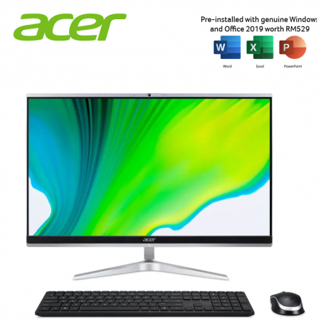

RM3,399.00

**CPU Only**

Acer Nitro 50 Gaming Desktop (N50-120-5700W11G)

<https://shopee.com.my/Acer-Nitro-50-Gaming-Desktop-(N50-120-5700W11G)-i.215858870.9797421006?sp_atk=66a59fe2-41c7-435a-8599-9b939022ebf7>

**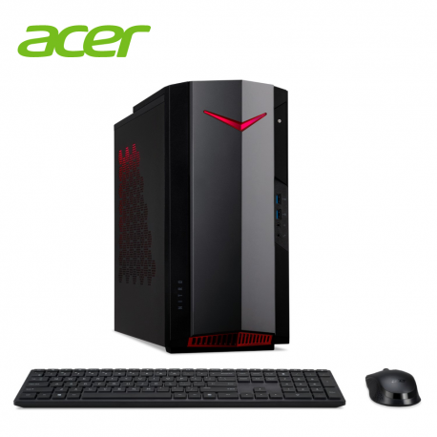**

RM6,499.00

Asus ROG Strix G10CE- 51140F282T

<https://shopee.com.my/Asus-ROG-Strix-G10CE-51140F282T-(i5-11400F-8GB-RAM-512GB-SSD-RTX3060-12GB-GDDR6-WIN10H-3YRS-WTY)-i.485755467.10276400283?sp_atk=ee801cfe-0817-4b44-b0a9-8f1c368a4dbf>

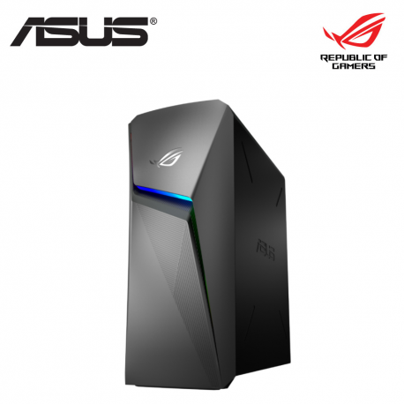

RM5,749.00

MSI Gaming Desktop MAG Infinite 11th Intel Core i5/RTX 3060 GDDR6/SSD

<https://shopee.com.my/MSI-Gaming-Desktop-MAG-Infinite-11th-Intel-Core-i5-RTX-3060-GDDR6-SSD-Free-Gaming-Monitor-Mouse-Keyboard-Cyberpunk--i.141942477.11010032040?sp_atk=47c301f6-a5c4-438b-ba59-a2f5e11d045c>

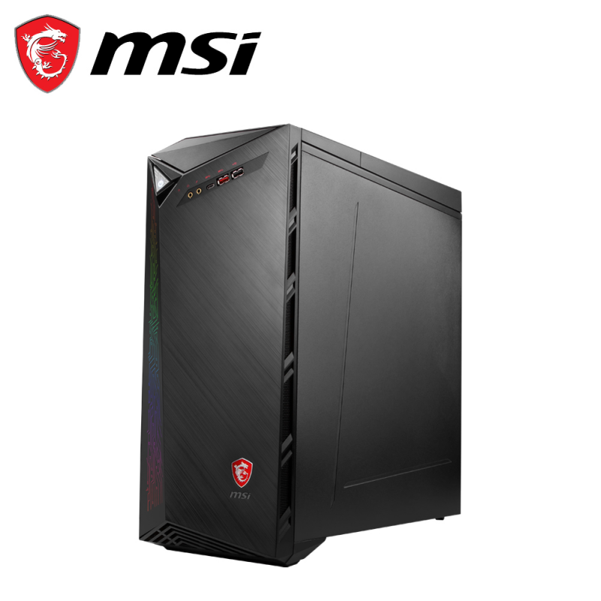

RM8,399.00

Asus Expertcenter SFF (S500SC-0G5905001T) Celeron G5905/ 4GB RAM/ 256G SSD/ Integrated/ W10/ USB Keyboard And Mouse

<https://shopee.com.my/Asus-Expertcenter-SFF-(S500SC-0G5905001T)-Celeron-G5905-4GB-RAM-256G-SSD-Integrated-W10-USB-Keyboard-And-Mouse-i.83072305.17937026062?sp_atk=b0edf2a7-ed91-4343-8216-63f8fdd7d0a7>

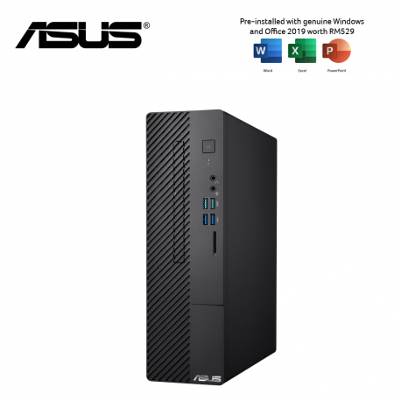

RM1,499.00

**Monitor**

ACER AOPEN 22CV1Q 21.5" 75HZ MONITOR

<https://shopee.com.my/ACER-AOPEN-22CV1Q-21.5-75HZ-MONITOR-i.213243429.6835981754?sp_atk=bd5f97ec-f000-41c0-950d-b849c29b9cb1>

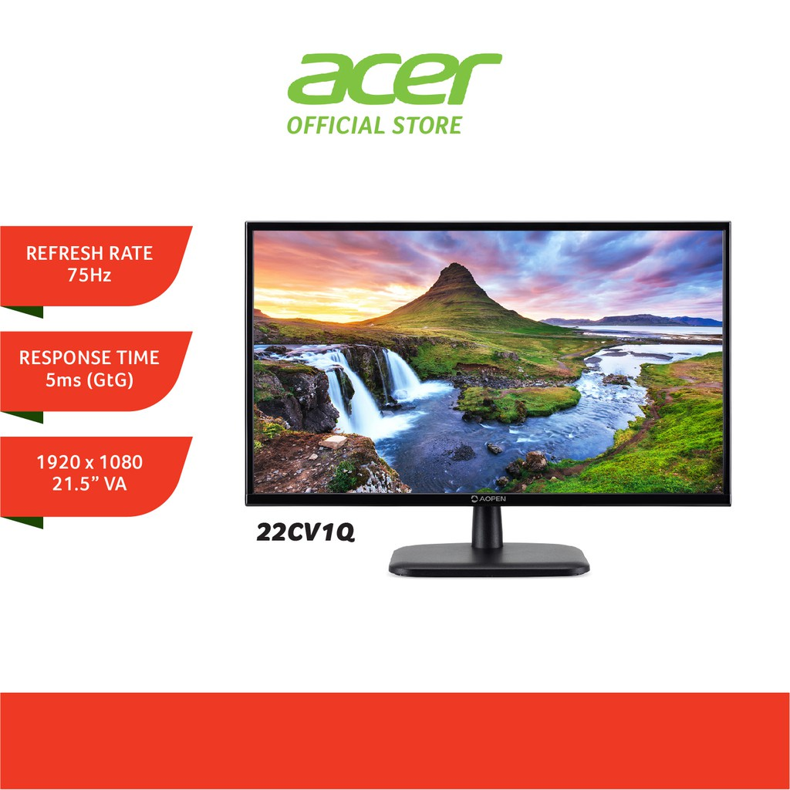

RM389.00

Acer Nitro EI322QURP / EI322QUR P 31.5" UWQHD 165Hz Curve Monitor

<https://shopee.com.my/Acer-Nitro-EI322QURP-EI322QUR-P-31.5-UWQHD-165Hz-Curve-Monitor-i.213234583.16025804280?sp_atk=bce486fe-223b-4c03-8918-b2a2e5d76e86>

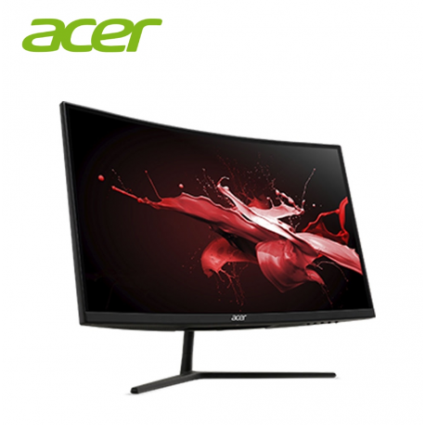

RM1,269.00

ViewSonic VX2758-2KP-MHD Flat 27" Gaming Monitor

<https://shopee.com.my/ViewSonic-VX2758-2KP-MHD-Flat-27-Gaming-Monitor-(IPS-Panel-QHD-1ms(MRPT)-Response-Time-FreeSync-144Hz-Refresh-Rate)-i.92746975.16500190507?sp_atk=0f39a80a-937d-42f9-9462-208c5490df42>

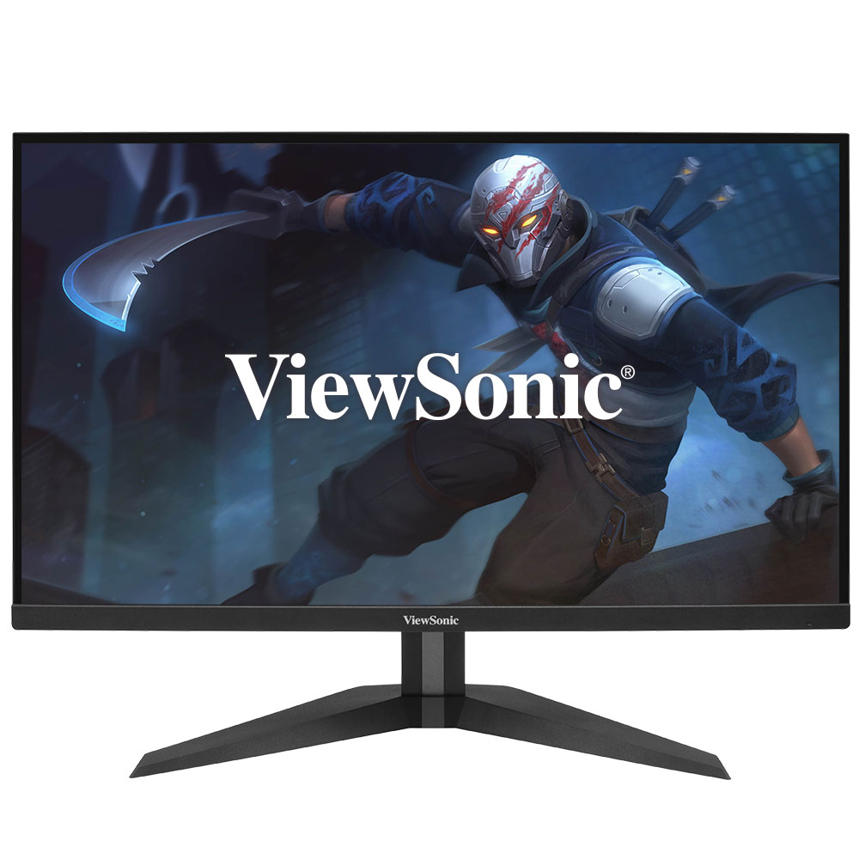

[RM999.00](https://shopee.com.my/m/authenticguarantee" \t "_blank)

Asus 4K 144Hz TUF Gaming Monitor VG28UQL1A Fast IPS UHD 1ms AMD FreeSync Nvidia G-Sync

<https://shopee.com.my/Asus-4K-144Hz-TUF-Gaming-Monitor-VG28UQL1A-Fast-IPS-UHD-1ms-AMD-FreeSync-Nvidia-G-Sync-i.143507751.11090307808?sp_atk=8f609181-0061-4a9b-90fd-ba4b20ec381d>

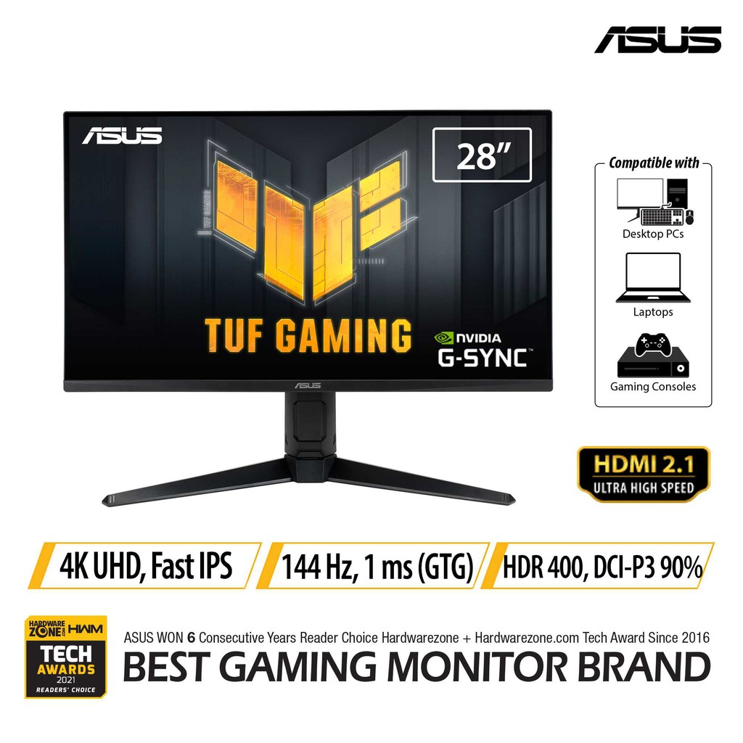

RM3,899.00